Virtual Clothes Try-on

Jorge Olivares

Robin Martinez

Alan Vela

**Functional System Requirements**

REVISION – 0.2

19 February 2022

Functional System Requirements

for

Virtual Clothes Try-on

Prepared by:

_____________________________

Author Date

Approved by:

_____________________________

Jorge Olivares Date

_____________________________

Prof. Kalafatis Date

_____________________________

Skyelar Head Date

**Table of Contents**

**Table of Contents III**

**List of Tables IV**

**No table of figures entries found. IV**

**List of Figures V**

**1.** **Introduction 1**

1.1. Purpose and Scope 1

1.2. Responsibility and Change Authority 1

**2.** **Applicable and Reference Documents 2**

2.1. Applicable Documents 2

2.2. Reference Documents 2

2.3. Order of Precedence 3

**3.** **Requirements 4**

3.1. System Definition 4

3.2. Characteristics 4

3.2.1. Functional / Performance Requirements 4

3.2.2. Physical Characteristics 5

3.2.3. Electrical Characteristics 6

3.2.4. Environmental Requirements 8

3.2.5. Failure Propagation 9

**4.** **Support Requirements 10**

**Appendix A Acronyms and Abbreviations 11**

**Appendix B Definition of Terms 12**

**Appendix C Interface Control Documents 12**

**List of Tables**

**Table 1. Assigned Responsibilities 5**

**List of Figures**

**Figure 1. System Overview Flowchart** **8**

# 

# 

# Introduction

## Purpose and Scope

The Virtual Clothes Try-on application is a more effective way of shopping online. It will provide a visual of how different clothes will fit. The document will help to identify the requirements for the Virtual Clothes Try-on project. An overview of the system and how it is divided is given in figure 1.

## Responsibility and Change Authority

The team leader is going to be responsible for the approval of any changes done to the project and that the desired requirements are met in the provided deadlines. These changes need to be accepted by the sponsor before actual implementation. Subsystems responsibilities are shown in the following table.

|  |  |
| --- | --- |
| **Subsystem** | **Responsability** |
| 3D People Model application | Robin Martinez |
| UI Design and security | Alan Vela |
| Cloud Database | Jorge Olivares |

Table 1 - Assigned Responsibilities

# Applicable and Reference Documents

## Applicable Documents

The following documents, of the exact issue and revision shown, form a part of this specification to the extent specified herein:

|  |  |  |
| --- | --- | --- |
| **Document Name** | **Revision/Release Date** | **Publisher** |
| Video Based Reconstruction of 3D People Models | 2018 | Computer Vision Foundation |
| Detailed Human Avatars from Monocular Video | 2018 | Computer Vision Foundation |
| MySQL Manual | 3.08 | Oracle Corporation |

## Reference Documents

The following documents are reference documents utilized in the development of this specification. These documents do not form a part of this specification and are not controlled by their reference herein.

|  |  |  |
| --- | --- | --- |
| **Document Name** | **Revision/ Release Date** | **Publisher** |
| People Snapshot  Datasheet | 2018 | Computer Vision Foundation |
| semantic human texture stitching | 2018 | Computer Vision Foundation |

## Order of Precedence

In the event of a conflict between the text of this specification and an applicable document cited herein, the text of this specification takes precedence without any exceptions.

All specifications, standards, exhibits, drawings or other documents that are invoked as “applicable” in this specification are incorporated as cited. All documents that are referred to within an applicable report are considered to be for guidance and information only, except ICDs that have their relevant documents considered to be incorporated as cited.

# Requirements

This section is going to identify the minimum requirements needed for the application to work. These constraints were decided in an attempt to create a comfortable environment for the user and good reliability.

# System Definition

The virtual clothes try-on system will be split in three different subsystems: Neural Network, UI application, and Cloud Database. The neural network is going to be the main focus of the application since it is going to create the 3D model of the user with a video recording. Additionally, it will allow the user to change the textures of the model allowing different designs on the avatar. The UI application will interact directly with the user of the application. This subsystem has to ensure user satisfaction and be easy to use. Moreover, it will take care of the security of the user when their information is used. Lastly, we have the cloud database. The database is going to store different designs of clothing the user will be able to change the 3D model. Also, it will store the 3D model with the information of the user. Preventing the user from having to record themselves every time they want to use the application.

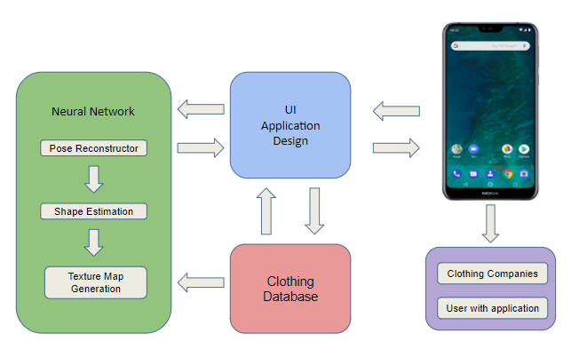

Figure 1 - System overview flowchart

## Characteristics

### Functional / Performance Requirements

#### Video

The video rendered by the neural network has to be at least 24 frames per second, 30 second video, and colored.

*Rationale: This is a core system performance requirement that the software requires to render the video.*

#### Analysis Time

The total time needed to evaluate the video to render a 3D Model should not exceed 45 seconds.

*Rationale: The time needed to render a 3D model should not take a long time for the user to see a result.*

* + - 1. **Database Size Requirements**

The database should be able to hold 50 to 100 different textures of shirts and trousers

*Rationale: Specified by sponsor*

### Physical Characteristics

#### Android Phone

The user has to have an android phone that can use OS 7.0 Nougat that is compatible with Augmented Reality applications. A back camera is required.

*Rationale: This is a requirement specified by the sponsor.*

### Software Requirements

#### Use of SMPL

The detection and characterization algorithms will use the SMPL model to track the pose of the User

*Rationale: A learned model of human body shape and pose-dependent shape variation that is compatible with the Python coding language*

* + - 1. **Programming Language - App Subsystem**

The Android application will be coded using Java

*Rationale: Due to constraints set when one is using Android Studio to design an app*

* + - 1. **Programming Language - Machine Learning Subsystem**

The github repository on the “Detailed Human Avatars from Monocular Video” will be translated from Python 2.6 to python 3.6

*Rationale: Specified by the team sponsor due to the constraints of the report this project is building off of*

* + - 1. **Programming Language - Database Subsystem**

The database for User accounts and clothe textures will be written in SQL

*Rationale: The Python language is a cross-platform language that is easy to pick up for novice programmers.*

* + - 1. **Database**

The database will be constructed using MySQL

*Rationale: MySQL is an open source relational database management system.*

* + - 1. **Android Application**

The application will be designed using Android Studio

*Rationale: An integrated development environment for Google’s Android operating system that is very customizable for ease of use.*

### Communications Requirements

#### Database to Application

Python will be used to contact amazon storage services. The database is going to use SQL to have the proper organization of queries. Queries will be done in python to retrieve or store data from the SQL database.

#### Failure Propagation

Any exceptions are caught within the script of code and will throw errors to be

read by the user if one or all the subsystems is down. All data will remain safe in the database and a system restart should be prompted to the user. System failures caught in exceptions will be analyzed for future resolutions.

# Appendix A: Acronyms and Abbreviations

MySQL My Structured Query Language

GUI Graphical User Interface

RGB Red Green Blue

SMPL Skinned Multi-Person Linear Model

3D 3-dimensional

IP Internet Protocol

# Appendix B: Definition of Terms

Neural Network - A series of algorithms that attempt to understand relationships between data sets that they receive.